Assignment 3
Yaoding Chen

Notebooks:
- Q1: https://colab.research.google.com/drive/1hCUuTwKADArfOAC12neiauQMIeSuadV2?usp=sharing
- Q2a training: https://colab.research.google.com/drive/1MxuBQ0RPlqkP75eJJdiVybbupCtaSaVZ?usp=sharing
- Q2b training: https://colab.research.google.com/drive/1CAynf8nD-nFv5rQLXgenrK9qjfqzYsg_?usp=sharing
- Q2 comparison: https://colab.research.google.com/drive/1i2C_mNQOjoIfKodu8IGEaoWoHZ3prgXO?usp=sharing

Question 1. Implementation of deep learning algorithms.

Please read the code in the Jupyter Notebook attached.

Question 2. Training image classifier with and without batch normalization.

Here we construct two models as follows:

Q2a. Without BN | Q2. With BN
Model: "sequential_2"  _________________________________________________________________  Layer (type) Output Shape Param #  =================================================================  conv2d_16 (Conv2D) (None, 32, 32, 16) 448  conv2d_17 (Conv2D) (None, 32, 32, 16) 2320  max_pooling2d_6 (MaxPooling (None, 16, 16, 16) 0  2D)  conv2d_18 (Conv2D) (None, 16, 16, 32) 4640  conv2d_19 (Conv2D) (None, 16, 16, 32) 9248  max_pooling2d_7 (MaxPooling (None, 8, 8, 32) 0  2D)  conv2d_20 (Conv2D) (None, 8, 8, 64) 18496  conv2d_21 (Conv2D) (None, 8, 8, 64) 36928  max_pooling2d_8 (MaxPooling (None, 4, 4, 64) 0  2D)  conv2d_22 (Conv2D) (None, 4, 4, 128) 73856  conv2d_23 (Conv2D) (None, 4, 4, 128) 147584  average_pooling2d_2 (Averag (None, 1, 1, 128) 0  ePooling2D)  flatten_2 (Flatten) (None, 128) 0  dense_2 (Dense) (None, 10) 1290  =================================================================  Total params: 294,810  Trainable params: 294,810  Non-trainable params: 0  _________________________________________________________________ | Model: "sequential_3"  _________________________________________________________________  Layer (type) Output Shape Param #  =================================================================  conv2d_24 (Conv2D) (None, 32, 32, 16) 448  batch_normalization_8 (Batc (None, 32, 32, 16) 64  hNormalization)  conv2d_25 (Conv2D) (None, 32, 32, 16) 2320  batch_normalization_9 (Batc (None, 32, 32, 16) 64  hNormalization)  max_pooling2d_9 (MaxPooling (None, 16, 16, 16) 0  2D)  conv2d_26 (Conv2D) (None, 16, 16, 32) 4640  batch_normalization_10 (Bat (None, 16, 16, 32) 128  chNormalization)  conv2d_27 (Conv2D) (None, 16, 16, 32) 9248  batch_normalization_11 (Bat (None, 16, 16, 32) 128  chNormalization)  max_pooling2d_10 (MaxPoolin (None, 8, 8, 32) 0  g2D)  conv2d_28 (Conv2D) (None, 8, 8, 64) 18496  batch_normalization_12 (Bat (None, 8, 8, 64) 256  chNormalization)  conv2d_29 (Conv2D) (None, 8, 8, 64) 36928  batch_normalization_13 (Bat (None, 8, 8, 64) 256  chNormalization)  max_pooling2d_11 (MaxPoolin (None, 4, 4, 64) 0  g2D)  conv2d_30 (Conv2D) (None, 4, 4, 128) 73856  batch_normalization_14 (Bat (None, 4, 4, 128) 512  chNormalization)  conv2d_31 (Conv2D) (None, 4, 4, 128) 147584  batch_normalization_15 (Bat (None, 4, 4, 128) 512  chNormalization)  average_pooling2d_3 (Averag (None, 1, 1, 128) 0  ePooling2D)  flatten_3 (Flatten) (None, 128) 0  dense_3 (Dense) (None, 10) 1290  =================================================================  Total params: 296,730  Trainable params: 295,770  Non-trainable params: 960  _________________________________________________________________  <matplotlib.image.AxesImage at 0x7f6e4d759cd0>

Model without BN, original data  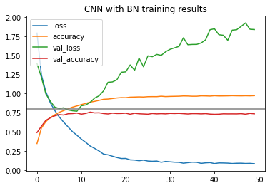  Model without BN, augmented data  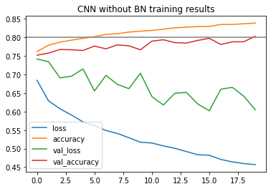 | Model with BN, original data  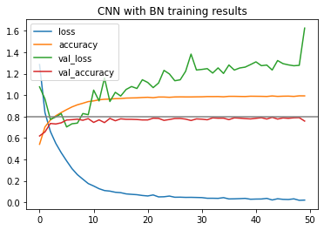  Model with BN, augmented data  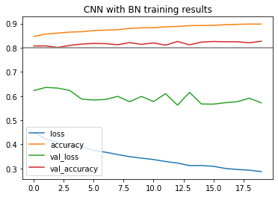

After learning rate and other hyperparameter tuning, the accuracy of the model in the training set is close to 100% and the validation accuracy stabilizes at 76.36% and 79.58% respectively. Further improvement to the models is extremely hard unless the dataset is augmented. Still, in both cases, the models with BN have higher accuracy than those without BN.

The training details are available at the two attached Jupyter Notebooks.

Below we show the feature maps of the average activation of layers, which may help to explain what contribute to our observations. The right one is using batch normalization, which shows a much faster learning rate. In CNN, since the filters to each layer are shared across feature map, normalization of the output is thus shared across the feature map. This has three effects on learning:
- First, normalization and standardization can make training faster. This is consistent with our training results, where the model with BN has much faster learning rate, as shown on the figures above.
- Second, Batch Norm reduces the internal covariate shift of the network. Thus, the amount of change in the distribution of the input of layers is reduced.
- Third, it seems that Batch Norm has a regularization effect thanks to minibatches that regularizes the loss, thus reducing the effect of noise. This explains much faster and more accurate learning we see in the following feature maps. The code to achieve this is at .

Mode without BN (left) vs model without BN (right)

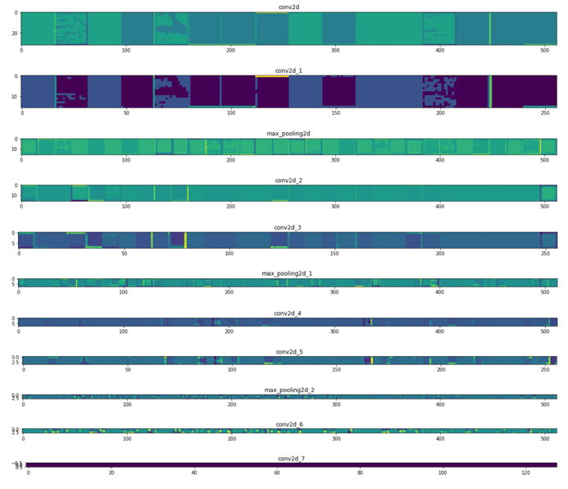 | 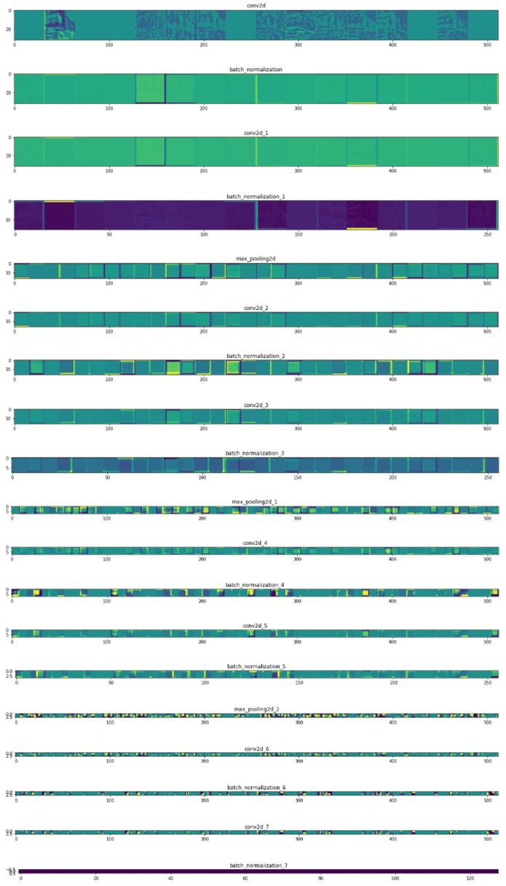

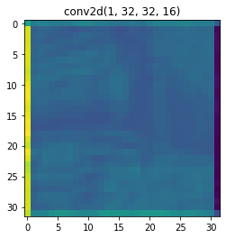  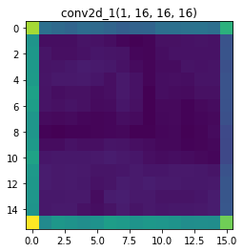  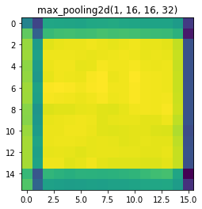  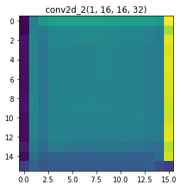  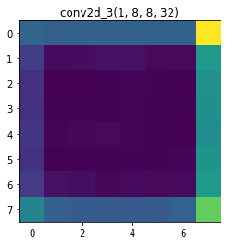  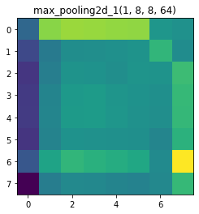  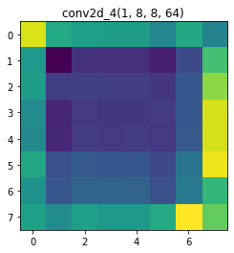    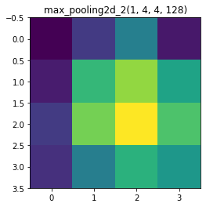  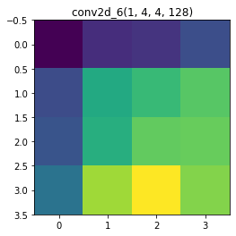 | 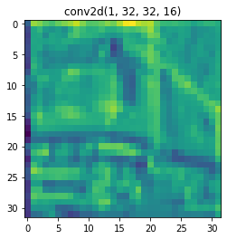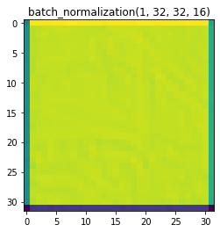  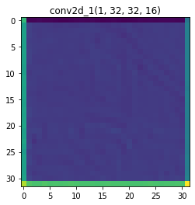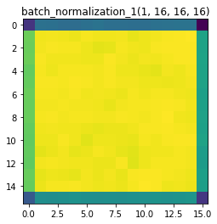  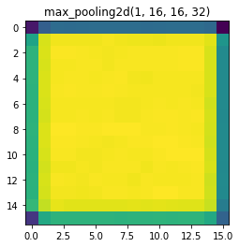  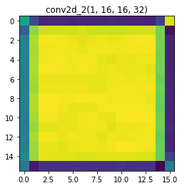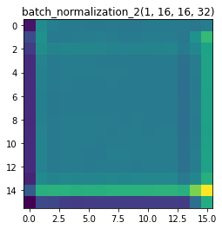  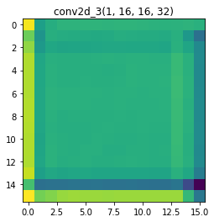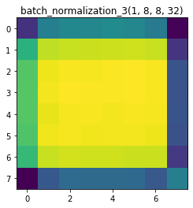  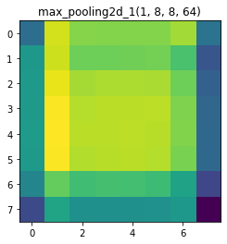  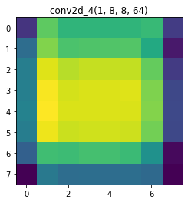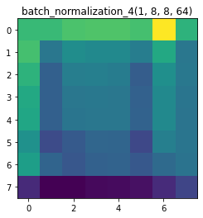  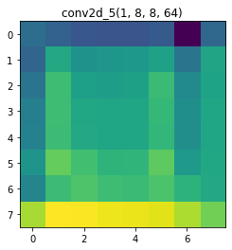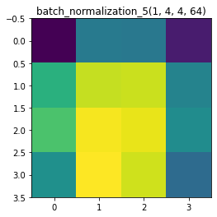  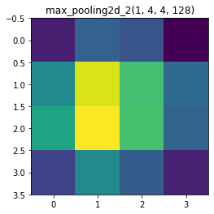  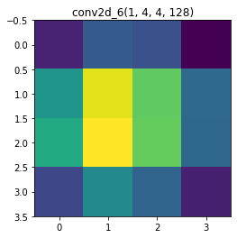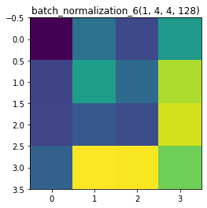

https://colab.research.google.com/drive/1hCUuTwKADArfOAC12neiauQMIeSuadV2?usp=sharing
https://colab.research.google.com/drive/1MxuBQ0RPlqkP75eJJdiVybbupCtaSaVZ?usp=sharing
https://colab.research.google.com/drive/1CAynf8nD-nFv5rQLXgenrK9qjfqzYsg_?usp=sharing
https://colab.research.google.com/drive/1i2C_mNQOjoIfKodu8IGEaoWoHZ3prgXO?usp=sharing

